Milestone 2 – Medium Planning

For my project, I’ve chosen to take the role of a communications officer for a political campaign. The cost of childcare is going to be a political topic within the next election, and we will address the topic across 3 mediums with 3 audiences. Each medium was selected as the most effective communication channel for its respective audience. Generation Z and Millennials spend much of their time on their smartphones. Consequently, short-form videos, such as those on TikTok, are more engaging for this demographic. Therefore, we will utilize short-form videos for this audience. In contrast, Generation X and Baby Boomers favor physical copies. They will receive an infographic printed on paper. Additionally, we will distribute an internal PowerPoint email to our staff to ensure they are informed about the policies and positions.

Medium 1 – Short form video
Audience – Gen Z, Millennials
Summary: The video must present the data and message within a 30-second timeframe. While the video will be concise, it is crucial to avoid overwhelming the viewer with excessive data. The video will outline the problem and transition three times to three distinct data visualizations. The initial visualization will elucidate the problem, while the subsequent visualization will provide additional information from a different perspective. The final visualization will serve as a conclusion, presenting solutions to the identified problems and outlining a potential trajectory.
 | 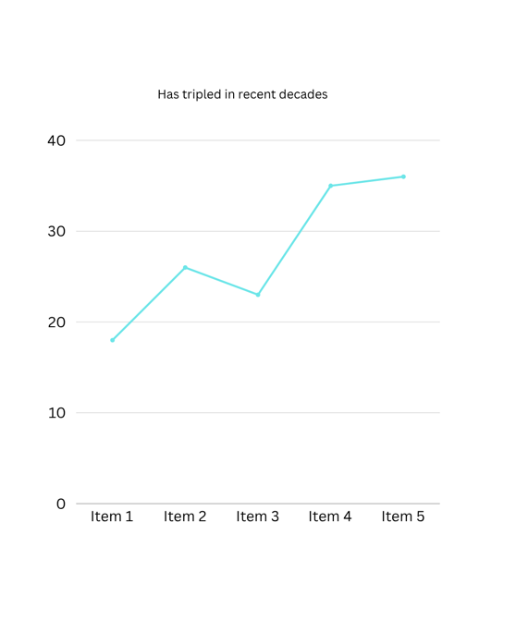 | 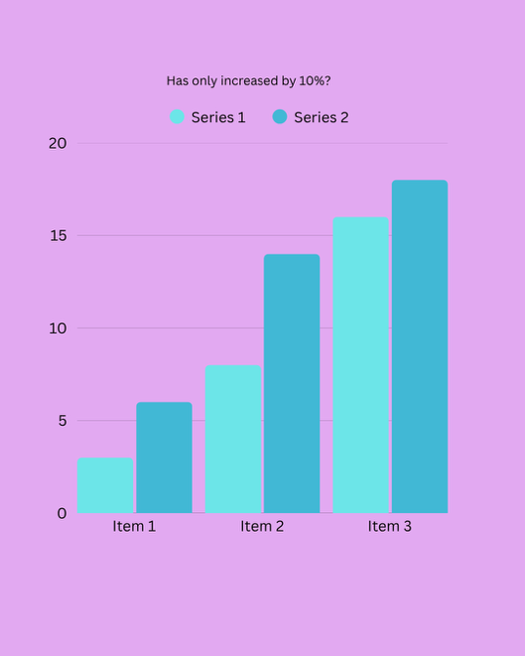

Medium 2 – Single page PDF printout
Audience – Millennials, Gen X, Boomers
Summary: A comprehensive PDF document will provide a detailed synopsis of the problem and our proposed solution. This document will include five visualizations accompanied by paragraphs that elucidate the problem and our recommendations. This document will be distributed to individuals who request physical copies of the policy. Distribution will be facilitated through our in-mail and door-to-door campaign.

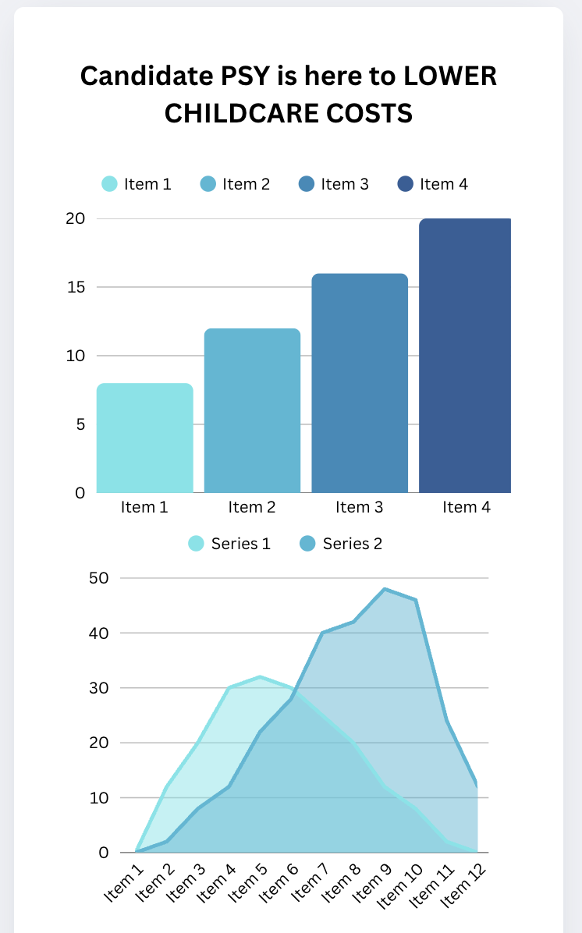
Medium 3 – PowerPoint
Audience – Campaign staff
Summary: As the campaign progresses, our staff is expected to be familiar with the policy positions of our candidate. A PowerPoint presentation, containing various slides outlining the issues and proposed solutions, will be distributed to each staff member. This presentation should provide them with sufficient information to address any inquiries regarding the campaign’s stance should they arise.

